Pontyclun Athletic Club August 2018
Pontyclun Athletic Club is a competing Club
Welsh Junior League West-Swansea .
12 athletes competed in the 4th Junior league at Swansea. While I was away in sunny Budapest, the storms hit the Riviera of South Wales. Several of our athletes did not compete, while others could only manage 1 or 2 of their events. Conditions were not good for performances, very few managed to improve previous bests and only 1 club record was achieved. After our tremendous successes at Neath and Brecon, with our team already ravaged by holidays, stormy weather was not welcome. Over to those who did manage to compete. Rhianon Pugh; Imogen Cutter; Lani Jones; Isobel Macintyre; Aaran Nathan; Alfie Rahilly; Noah Gregory; Mia Williams; Tara Nathan; Lucy Fisher; Caitlyn Richards; Seren Hardwidge; Tom Harry. Rhianon finished off the Junior league series with a excellent 11.8sec for the 75m. The ever improving Imogen also a good time with 13.2. Lani also ran, sorry Lani, I do not have a time for you. In the u11b 75m, Alfie ran a 12.4secs, one of the few pbs of the day. Noah with 13,0secs. Tara the 800m in 2.37.9mins not her best but in the conditions it was an excellent run. Don't know what happened to Tom, guess he must have slipped off the blocks? You must compete more Tom, you have lost so many opportunities in your last year in the u15 age group. U17 will be far more competitive. And that's all the track events. In the field, Rhianon had a reasonable Long jump with 2.82metres, Isobel with 2.14metres. Lani on the score board with a good first time jump of 2.58metres. In the boys u11 long jump, Aaran with 2.62metres and Noah with 2.12metres both well below their best. In the Javelin Mia also a little below her best with 19.45metres, again the conditions may not of been helpful. Ben achieved 12.05metres in his 1st Discus competition and a 5.09metres for the Shot. Finally the u15g shot putt and our best results of the day. Lucy who has been setting club records from the time she first competed for the club 6years ago, Achieved her swansong with another club record a 7.23metre Shot putt (wind assisted of course ha ha) improving her previous best by over half a metre. She was ably supported by Seren who in her first competition putt 6.48metres, excellent work girls
Carmarthen Throws Earlier in the week, 3 of our athletes took part in the Carmarthen throw series. It was a successful night for Eurion John who has taken to the Javelin like the proverbial 'duck to water'. An excellent throw of 24.86metres places him 12th in the power of 10 rankings (2nd in his age group) all in his 1st comp, excellent work Eurion. End of the season blues for Mia Williams, Javelin 18.16metres and a Discus not her Favourite of 12.99metres, both well below her best. I bet dad Jamie took some stick. A better night for Lucy Fisher in her first Carmarthen throws comp a Javelin throw of 14.42metres near her best and a Discus throw of 14.46metres just 0.02metres off her best.
Junior league Plate Final For the first time ever we competed in the JLPF. We formed a Combined team with Barry and Vale, although we were 7th out of the 8 clubs we beat our RCT neighbours the combined team of Rhondda / Aberdare (199) by over 300points. Our personal tally of 240 points was enough. There we 4 clubs including our combined team on around 500points, so very close. It was another damp day at Swansea and not conducive to good performances. PAC supplied 11 athletes, Lani Jones; Sophie Thomas; Isobel Macintyre; Aaran Nathan; Rhys David; Tara Nathan; Ciara Lang Thomas; Ben Evans; Max Arnold; Osian Parry; Eurion John. Isobel Arnold dropped out the day before with a back problem, she however attended the meeting and gave generous support to her team mates. Lani in just her 2nd competition both at Swansea in the rain, must be wishing she took up swimming. A 75m in 14.67secs and a LJ of 2.43metres, also running a leg of the relay, she still enjoyed her day. Sophie ran the 150metres in 25.07 and had a Shot putt of 4.76metres both below her best. In the LJ although still a little disappointed with her performance jumped a pb of 3.19metres (best in club u11g this year) Sophie and Tara were the girls joint best points scorers with 22points. Isobel's Shot putt was a little below her best with 3.68metres. In the 800metres it was another pb by split secs in 3.03.66min. Aaran was almost ordinary, a 150m in 24.87secs just below is best. A frustrating 800m got himself boxed a couple of times tried to get through on the inside eventually had to go the long way out of the back and around the outside by this time the leader had a 20metres lead which was too far much for him to make up, eventually finishing second in a time of 2.49.09mins a time that most 9year olds ( 9 this week) would be very pleased with. Rhys had a very good day a pb in the LJ with 3.44metres and another in the 800m with a time of 2.56.89mins good work Rhys keep improving.Tara not feeling very well bravely competed in the 200m and 800metres. Easily won the 800metres in 2.37.16secs no competition to push her to a faster time. There was little time between the 8 and 2 and her time of 31.20secs showed this. Ciara ran the 800m in 3.12min and then followed with a 200m in 33.39secs both below her best. Ciara also competed in the HJ which I think could be her best event, the conditions we terrible with pools of water in front of the jump, Ciara managed 1.15metres she is capable of 1,25/30metres. Ciara also accumulated 21point for the team. Between them the u13b accumulated 112points. Ben picked up 2 pbs a Javelin throw of 17.04metres and a Shot putt of 5.88metres in only his second Discus competition he threw 11.89metres, ( and 29points) Osian, another athlete who was not totally satisfied with his day a 100m in 14.95secs, a 200metres in 30.49secs (his fastest outdoor time) and a LJ of 3.73metres.( I would have predicted Osian jumping nearer 4.40metres by the end of the summer after his 4.15metres early in May, lack of practice and competition may be the problem) Osian was our top points scorer with 34 points, so cheer up. Max who was our B competitor to Osian's A was 1st in the 100m with 15.07secs, 2nd in the 200m with 31.06sec and 1st in the LJ with a pb of 3.56metres, good work Max. Eurion won the Javelin with a throw of 23.14metres, before finally running across to the relay to help the relay team to a 2nd place and finish our damp day in Swansea. More numbers competing at Carmarthen (junior league 1) and reasonable weather conditions at Swansea, we would have been competing the plate as a PAC team. We have the athletes to do that, let's make sure we do it in 2109
Power of 10 (2018 Welsh rankings) Mia as 3 entries in the pof10-3rd in the Shot with 8.13metres-3rd in the Javelin with 24.71metres and 20th in the Discus with 14.42metres. Nia with 2 entries, 200metres time of 30.61secs is 7th 1st year Pof10. Nia's long jump of 4.14metres is 14th (2nd 1st year) Pof10. Isobel in for the first time with a 4.11metres at 15th for the Long jump. Osian also as 2 entries a long jump of 4.15metres 11th (6th in 1st year) and a 200metres in 29.36secs 19th (6th in 1st year) Tara excellent 2.35.81mins in the 800metres is 9th. Tara also in with a 29.83secs 200metres is 24th. Dylan Williams is also new in with a 1.55metres Highjump. 1 new entry Eurion John in the Javelin 24.86 pof 12th (2nd 1st year)
Gwent League Cross Country Fixture and Dates 2018-2019
13 October 2018 - Llandaff Fields, Cardiff. In conjunction with the Cardiff Cross Challenge. (will report on this in the next newsletter)
10/11 November 2018 - Pembrey Park
1/2 December 2018 - TBA
Cross Country information and advice A Club vest is required to compete. Running spikes are essential, Replace track spikes with longer ones. Be prepared for our changeable weather conditions Warm clothing thermals gloves long running tights and rain proofs, water or energy drinks for athletes tea or coffee for the supporters. Although there will be food and drink available at all the venues. Inform Geraint, Jamie and I of your intention to compete if you fail to do this you will not be entered. Age groups similar to junior league u11, u13, u15 and older age groups up to veteran 70+. We do have to register for the series so obviously interest is required. More information to follow.
Pontyclun Athletic Club is a competing Club The club is a competing athletic club. We are not a fitness club we coach athletics. Geraint, Jamie and I are not paid. We coach athletics because we are enthusiastic about the sport. There have been several athletes who have not competed in any track and field events this year and some who think once is also enough.
Hooded tops,T shirts, hats and Club Logo: Still available let's look like a team for the Summer.
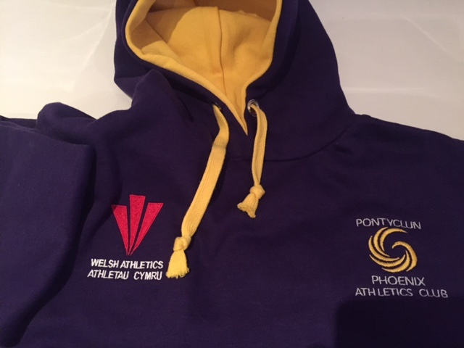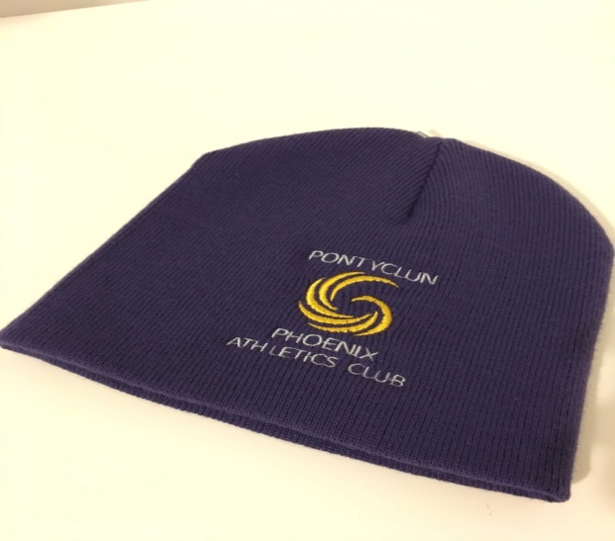
Club Web Site Jamie is our club web site manager. Any suggestions for our web site speak text or e mail Jamie, does anybody have any experience in designing web sites, and could assist Jamie. Please send your comments/photos etc.
Child Safety: Will all parents please meet (collect) their children from the gym/field rather than wait for them outside. For the safety of your children, the club is responsible for their well being.
Club Night: The groups to each session are. In the first session are Simeon Richards; Rhiannon Pugh; Robyn Bolinger; Lily Davies; Mali Williams; Imogen Cutter; Tom Prys Evans; Elan Williams; Noah Gregory; Isobel Macintyre; Sophie Thomas; Libby Enamuel; Nia Akers; Lani Jones; Alfie Rahilly; Rhys David; Millie Lewis; Coral Michie; Harri Woolston; Efa David and new starters James Howell; Gethin Collier; Rylan Wilmington; Taylor Hinkinson;
In the second session Aaron Nathon, Ben Evans; Max Arnold; Caitlin Richards; Lucy Fisher; Bethan Lang-Thomas; Ciara Lang-Thomas; Isobel Arnold; Mia Williams; Tara Nathan, Mali Thomas; Morfudd Jones; Nia Powell; Bethan Davies; Alex James; Tomos Harry; Osian Parry; Heidi Stamp; Paige Evans, Phoebe Clarke, Jaydyn Young, Faith Thomas, Dylan Mahoney, Seren Hardwidge, Charlotte Driscoll; Eurion John; Dylan Williams.
Training Night. Training resumes on Thursday September 6th, 6pm to 7pm for the first group and 7pm to 8pm for the 2nd group. There will be 14 sessions in the period up to mid December, The cost will be £25 to be paid preferably by cheque on the 1st night. The payment will be collected by our Treasurer Jane Bowns who will also issue a receipt for the payment. If you have decided not to continue being a club member I would be grateful if you could inform me asap. We do have a waiting list.
New Coaches A big thank you to Anwen Gammon and Bethan Evans for their work with our middle distance runners through the summer. Bethan has now gone back to her University in the state of Alabama,USA. we wish all the best in her studies. Anwen has decided to stay on a permanent basis and will be doing her coaching qualification this Autumn. There was a obvious improvement in our middle distance athletes and also an increased number taking part, great work girls and great to have Anwen on board. If you are interested in coaching, doing the coaching qualification or have some experience in perhaps one athletic discipline and can help occasionally. If interested contact our coaching team.
Track and Field Officials Some parents have helped with the various aspects of officiating and the coaching team thank you for your help. You may have noticed that unlike other clubs we do not have qualified officials. With the number of our athletes increasing we may not be allowed this concession much longer. I suggest that by next year we get 6 volunteers qualified to level 1. I will provide more details of this course asap. If interested contact our coaching team.
Membership and Welsh Registration Thank you we now have 45 paid up members, and 7 newcomers starting in September. Outstanding club memberships will be collected during September but not on the 1st night.
Club Vests Club vests are required to compete in all athletic competition. All members over the age of 9 will be eligible to compete. Club Vests cost £10 to £12.50p (we do have some used vests that will cost £5) As a member you need a club vest please contact me with the size you require. If your present vest is too small you can change it for a larger one and get £5 towards your new vest.
Club Venue/Athletic Facilities/Funding. The big news, is that it was recently announced by RCT( I was informed several days earlier by Owen Smith MP) that a 6 lane 400metre track with 100metres straight is to be constructed at Bryn Celinog school in Beddau. Work is to start in the Autumn and completed by the Spring 2019. To date no information on jumps or throws. I would be interested to hear members and parents comments. NONE SO FAR
Club Committee, Track and Field Officials Our present committee consists of 10 members, however 2 are coaches; 2 are welfare officers and 1 is the club captain, who are all welcome and entitled to attend meetings, they are not strictly committee members. We therefore require perhaps another 2 committee members if you are interested in becoming more involved please contact our club secretary
Chair-Rowland Williams Secretary-Clare James Treasurer-Jane Bowns Team Manager-Geraint Evans Web site Manager-James Williams Welfare Officer (male)-Paul Arnold Welfare Officer (female)-Gwyneth Watkins Club Captain-Lucy Fisher Committee members- Lisa Powell, Helen Fisher.
Newsletter If you wish to contribute to the club letter or have any comments or ideas that may improve the club please contact. Decisions on the format and method of distribution of the club newsletter will be discussed at the next committee meeting.
Rowlie, Geraint and Jamie
Rowland- Home-01443226425- Mobile – 07842308985 E-mail- rowland_williams3@sky.com
Geraint-Home-01443222025-Mobile- 07779851697 E-mail-geraint.evans@perkinelmer.com
Jamie Williams-Mobile 07876504651 E-mail- jtwilliams54@yahoo.co.uk

